**Assessment of MOVIES**

**By Harsh Raj**

**J011**

**Various Factor used for comparing the Data are :**

**IMDb Rating vs Genre**

**Budget vs Genre**

**Production Company vs Budget**

1. IMDb vs Genre( With respect to the Budget)

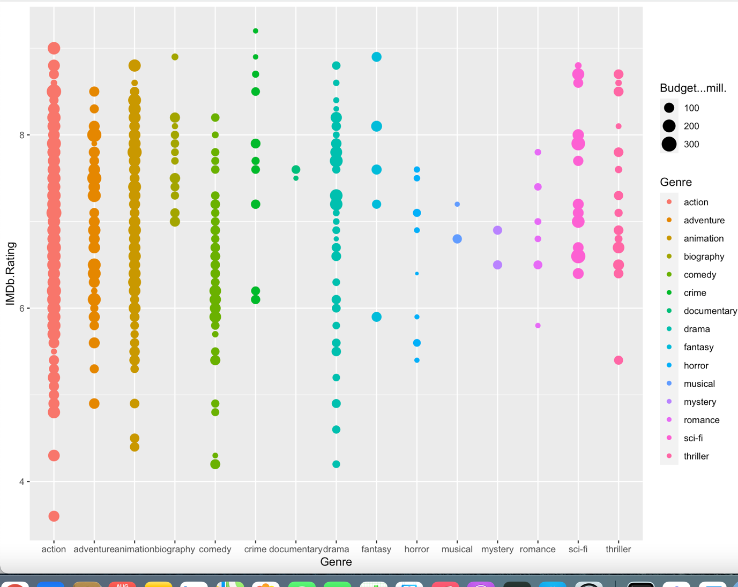

In this Point Chart WE can see That the Crime Genre Movies has Higher IMDb rating compared to other Genre and there Budget are also Less compared to the other Genre making it more Financially More Feasible . Or if the director want to do something New it can make a movie on the theme of Fantasy as we can see the number of movies are very less therefore scope is also very high.

2. **Budget vs Genre**

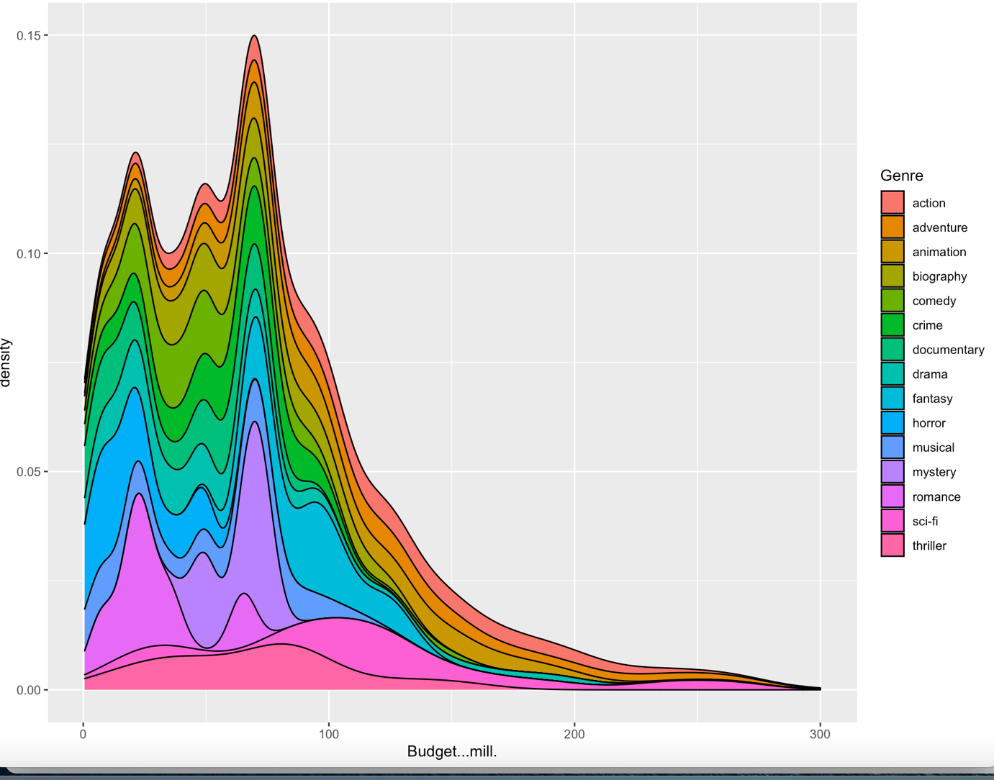

Infer- As we can see most of the data is positively skewed making most of the genre of the films vey feasible to make, Though We can see that the Number of Action Movie Made are higher and there budget is also One of the Highest , This is showing that the demand for the action movie and its investment are both the Maximum In the field .

3.Production Company VS Budget

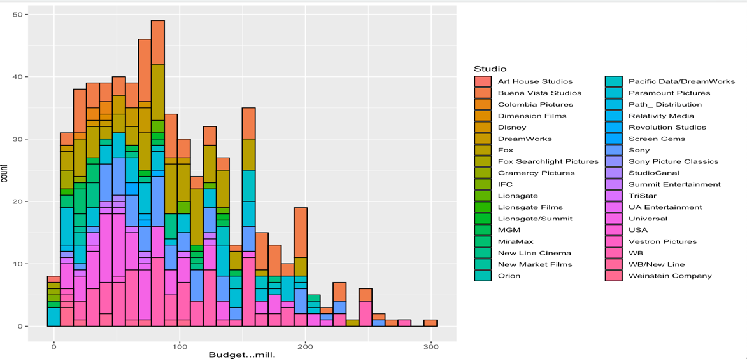

Infer- We can see through the data that Disney is one of the highest spender in terms of budget in the movie field as a director one can expect Disney To provide a more Ambitious project in terms of the Money hence more opportunity.

FINAL INFER

According to the analysis done above I can see that the Genre Crime and Action are the best two field to make the movie as per the budget and the IMDb rating and one can see that Disney being one the highest funder so for production purpose more scope is available with Disney.